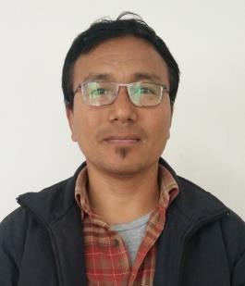
Mr. S. Anthony
Assistant Professor
Dept. of Political Science Modern College, Piphema
Email: anthony@moderncollege.edu.in
Contact: 9856 447787

Education:

Degree | University/Board | Year of Passing | Others
M.A. (Pol. Science) | Delhi University | 2001 | - Certificate in Computer Basics.  - UGC NET.
B.A. (Hon.) | Nagaland University | 1997
HSSLC/PU | NEHU | 1994
HSLC | NBSE | 1992

Employment Details:
Joined in September 2002 as an Asst. Professor, Dept. of Political Science, Modern College, Kohima.

Research Interests:
Local Self-Government.

Publications (if any):
Edited book titled ‘General Challenges: An Overview of North East India.’ ISBN-9788194760887.

Short term courses/Workshops/Seminars/Conference Organized or Attended:
- Organized a 2 Day ICSSR sponsored National seminar at Modern College Piphema in 2024.
- Presented paper in the ICSSR sponsored National Seminar in 2024.
- Attended a One Day National Seminar organized by the Research Committee, Modern College Kohima in 2020.
- Organized ICSSR (NERC) sponsored 2 Day National Seminar at Modern College Kohima in 2019.
- Attended and chaired a session in ICSSR (NERC) sponsored 2 Day National Seminar at Modern College Kohima in 2019.
- Attended a Two Week Capacity Building Programme in Social Sciences sponsored by ICSSR New Delhi organized by the Dept. of Education and Dept. of Teacher Education, Nagaland University, Meriema Campus in 2018.
- Attended NAAC sponsored 2 Day National Seminar in St. Joseph’s College, Jakhama in 2017.
- Attended an Orientation Programme for Academic Counselors organized by IGNOU at Guwahati in 2016.

*************************************************

