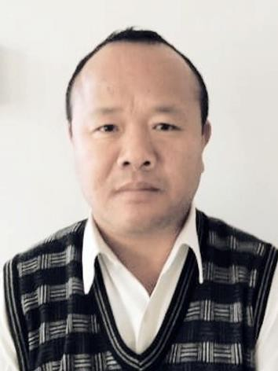Mr. L.Athikho

Assistant Professor

Department of Economics

Modern College, Piphema

Email:[athikho@moderncollege.edu.in](mailto:athikho@moderncollege.edu.in)

Mobile:-7005403779

Education Qualification:

|  |  |  |  |
| --- | --- | --- | --- |
| Degree | University/ Board | Year of passing | Subject |
| B Ed | MU | 2024 | Social Science |
| M.A, | N U | 2002 | Economics |
| B.A. | NU | 2000 | Eco. Hon’s |
| PU | NU | 1997 | Arts |
| HSLC | Manipur Board of Scholl  Education | 1995 | Eng, Manipuri, Maths, Science, Social science. |

Employment Details: Joined Modern College as Asst. Professor since 2003.

Publications: Nil

Short term courses/Workshops/Seminars/Conference Organized or attended:

1. **Attended Refresher Course organized by Tezpur University from 10-31 December. 2004 and obtained grade (A)**
2. **Attended UGC Sponsored Orientation Programme NEHU Shillong on 23/1/2017 To 19/2/2017 and obtained grade (A)**
3. **Attended Capacity Building Programme for Research Scholars Organized by Kohima College on 22 to 25 /2 /2016.**
4. **Attended National Seminar Organized by Pol. Science Dept. On 27and28 Nov2019**
5. **Organized one day Workshop on ‘IMPACT OF EDUCATION ON ECONOMIC DEVELOPMENT’ on 29/ 01/ 2020. Sponsor by SBI Main Branch Kohima**
6. **Organized National Youth Day and Youth Week in collaboration with NSS and sponsored by Nehru Yuva Kendra from 12-19 Jan. 2024.**
7. **Organized State Level Seminar sponsored by NABARD on 3rd Aug. 2024.**

**Sd**

**Mr. L. Athikho**

**HoD, Dept. Economics**